**Project Report**

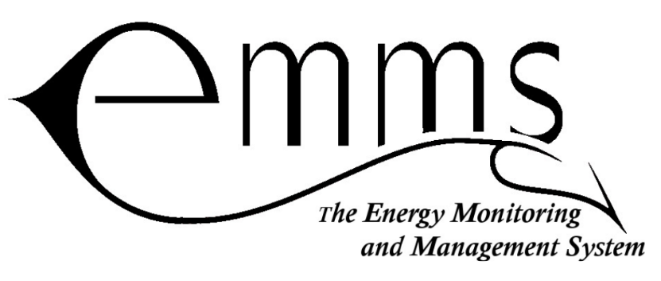

**Version 4.7**

**March 2021**

**Partner/Client**

Open Door Development

Matt Walsh

Mahadaga, Burkina Faso

011-226-70-80-69-60

[matt.walsh@sim.org](mailto:matt.walsh@sim.org)

Theological College of Zimbabwe

Ray Motsi

Bulawayo, Zimbabwe

[rgmotsi@gmail.com](mailto:rgmotsi@gmail.com)

**Project Team Members**

Bennett Andrews

Zach Gillen

Samuel Goertzen

Nick Hamann

Zachery Holsinger

Caitlin Ross

Ben Weaver

Seth Wilcox

David Williams

**Version History**

|  |  |  |
| --- | --- | --- |
| **Version** | **Date** | **Description/Notes** |
| **1.0** | **11/27/2017** | **Initial Report** |
| **2.0** | **4/2/2018** | **Revisions for MVP Cycle Spring 2018** |
| **3.0** | **10/5/2018** | **Revisions for first Project Review of Fall 2018** |
| **4.0** | **12/14/2018** | **Restructuring of Theory of Operation/Project Report Content** |
| **4.1** | **4/5/2019** | **Revisions for Project Review of Spring 2019** |
| **4.2** | **10/18/2019** | **Revisions for Project Review of Fall 2019** |
| **4.3** | **03/03/2020** | **Revisions for Project Review of Spring 2020** |
| **4.4** | **04/28/2020** | **Revisions for Second Spring 2020 Cycle** |
| **4.5** | **10/12/2020** | **Revisions for Project Review Fall 2020** |
| **4.6** | **11/24/2020** | **Revisions for First Project Review Lite** |
| **4.7** | **3/8/2021** | **Revisions for Project Review Spring 2021** |
| **4.8** | **3/25/2021** | **Resubmissions for Project Review Spring 2021** |

**Revisions Since Previous Version**

* Updated Goals for Project Review
* Additional topic of Java Backend added to Goal 4

**Table of Contents**

Abstract 4

Problem Definition 4

Project Overview 5

Spring 2021 Progress & Goals Overview 6

Goal 1 7

Goal 2 7

Goal 3 9

Goal 4 9

Goal 5 10

Conclusion 11

Future Goals 12

Appendix A: Project History 13

Appendix B: Past Project Records 14

Records for Board Designs: 14

Records for Testing: 14

Miscellaneous Records: 14

# Abstract

There exists a problem in developing countries involving energy conservation. In order to provide a practical way of controlling energy consumption and to create a tool for teaching energy conservation, Energy Monitoring and Management Systems (EMMS) was tasked to make an energy meter. This meter should be able to measure energy usage over a period of time and to prevent further energy usage after a specified amount has been consumed. The EMMS project’s largest client, TCZ, requested electrical meters for monitoring their energy usage in the Spring of 2018. The team delivered the physical meters however they do not have functional code. Currently, TCZ is not capable of managing the energy use of their student dormitories effectively. This document will provide information on the team’s work during the most recent work cycle of EMMS (January 2021– March 2021). This document also provides a brief introduction to the project before providing a description of the project’s status. The current status includes the goals for this work cycle and tasks underway to complete them within a timeline. Additionally, this document should help the reader to understand the EMMS team’s outlook for the rest of the year and long-term goals for the project. At the conclusion of the work cycle, the team has not yet finalized code to make the meters in TCZ functional, however there has been noticeable progress towards fixing errors and identifying the work that remains. The team made significant strides in this area, in addition to progress made towards future improvements to the meter.

# Problem Definition

There exists a problem in places where electricity is a much more expensive and limited resource. The goal of this project is to design and implement a reliable, manufacturable, and expandable system to measure, display, and limit the energy usage of a home or other facility to encourage energy conservation and financial frugality.

# Project Overview

Over Summer 2019, our project sent a site team to TCZ with the purpose of installing meters as well as connecting with our client. While the team installed 20 meters, shortly after leaving it was reported that the meters were not functioning as expected. Thus, our urgent focus is updating the meter firmware to fix these issues, as well as creating a user manual and other documentation useful for teaching users how to use and maintain our meter. Once these tasks are done, we will walk TCZ through the process of updating their meters using the PICKit we provided to them before leaving.

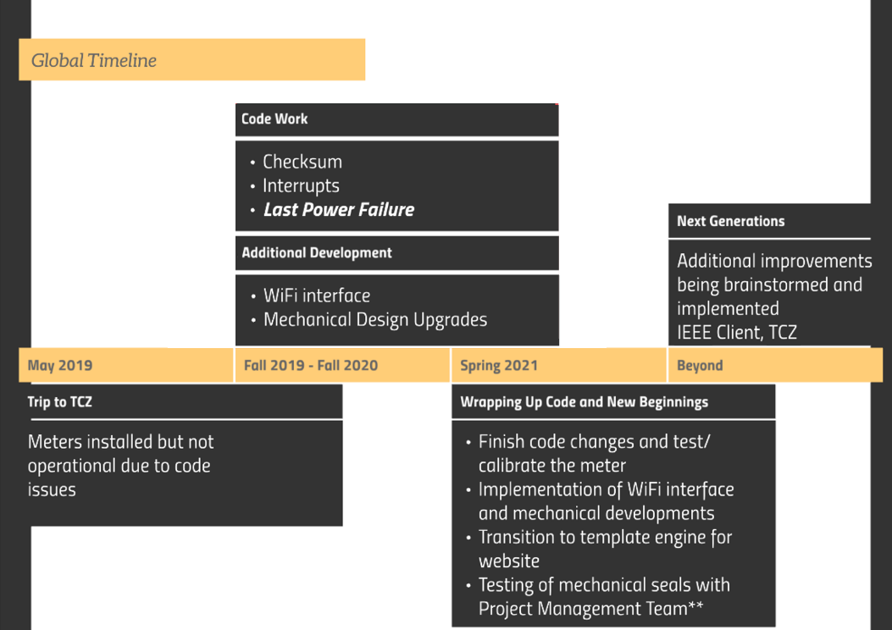

Figure 1: Global Timeline

Since then, there has been an overhaul of our code, and although there are still more steps to take, we are making strides towards a more consistent and fully functioning meter. The rest of this document will summarize this progress.

Additionally, the team has been making progress towards other areas of development. This includes adjustments to the layout of the PCBs within the enclosure and also expansion on the WiFi system being incorporated into the boards. The rest of this document will describe the work done in these areas and the progress towards the goals of the current work cycle.

# Spring 2021 Progress & Goals Overview

At the beginning of this project cycle, we defined goals as listed below:

1. Verify that the meter is fully functional with no bugs.
2. Cross-Verify to previously made checklist.
   1. Step 3 meters through the previously defined ‘Test Verification’ checklist.
   2. Refine the ‘Test Verification’ checklist to ensure all crucial items and subsystems are tested.
3. Assemble prototype meter with new PCB layout.
4. Develop new PHP website frontend template engine for system administrator user interface.
5. System server polls and stores live data read from the meters.

These are discussed below in addition to an unofficial goal of having underclassmen volunteers wire, program, and compile code on a PIC32.

## Goal 1

* Verify that the meter is fully functional with no bugs.

Most of this cycle was spent resolving the known bugs before tackling the verification of the meter. Specifically, the interactions with the on-board clock chip proved difficult in previous semesters, however the issues in the code related to these problems have been resolved. This completes the previous list of known issues that was developed in Fall 2019. In the remaining time of this work cycle, there has been a verification of the meter’s functionality, which has resulted in a list of further issues that must be addressed before beginning to test for consistency between meters. Of the remaining issues, there are few that are ‘necessary’ for the meter to function. Based on the analysis of the code issues, the team is hopeful that these problems can be resolved by the conclusion of the 2020-2021 academic year.

Further information regarding this goal can be found in the records *“EMMS Code Stability Improvements”* and *“EMMS Meter Performance Analysis.”*

## Goal 2

* Cross-Verify to previously made checklist.

This goal became incorporated into the work done towards Goal 1. Because there are still issues in the EMMS meter’s code, it did not seem practical to test three meters for differences. Instead, a single meter was tested to see what is still unresolved. The testing of the meter utilized the verification checklist indicated in this goal’s description and created a list of action items to be resolved in the next work cycle. Before using the checklist, minor refinements were made, but no significant changes occurred.

As with Goal 1, further information regarding this goal can be found in the record *“EMMS Meter Performance Analysis.”*

## Goal 3

* Assemble prototype meter with new PCB layout.
* New PCB design and enclosure layout.

The team furthered their effort in designing and constructing the new PCB layout. They were able to finish the new PCB design this semester and send it out to get printed. In addition, the team was able to fit together the boards for the first time with the new connection system. Moving forward the team will be finalizing and testing the new mounting design for the boards, as well as test the functionality of the boards to see if there are any notable improvements or issues with the new design.

Further progress towards this goal is documented in the record titled “EMMS Enclosure and UI Changes”.

## Goal 4

* Develop new PHP website frontend template engine for system administrator user interface.

During Cycle 3 of Spring 2021 the website moved all the HTML code into PHP file extensions. Migrating to PHP provided more flexibility of the functions of the website. This move also streamlined the development process, enabling new features like database querying to be done quickly and easily.

In addition to the migration into PHP, the administrative webpage received an overhaul in both aesthetic and functionality. The page’s color scheme was toned-down to reflect previous feedback from panelists and the layout has been advanced to include more features, and to make them changeable from the website. Pictures can be uploaded, and certain editable fields like tags can be changed via the administrative access page.

Progress towards this goal is documented in the record titled “HMI”

## Goal 5

* Polling the server and storing live data from the meters

In previous years a Java-based remote access tool (S.A.M.) was prototyped and tested at TCZ as a way for administrators to adjust the settings remotely and securely on installed meters. Part of this code involved talking to meters wirelessly through a 2.4GHz LAN network. This TCP communication and error control was organized by its own package and is being repurposed to gather meter data and place in now in the Website Database. This backend code contacts meters that share a LAN connection with the hardware running the database and places gathered meter-information into the database.

Progress towards this goal is also documented in the record titled “HMI”

# Future Goals

In the future, EMMS is looking to increase the usability of the meter and to simplify the installation process through documentation and client interaction.

Increasing the usability will come as a result of interactions with our current and potentially future clients. As they inform us of features that they would like, we plan to discuss these and potentially add them to the design. Currently, we have discussed possible additions of an RF version of our current Wi-Fi module and a DC version of our Power Sense board. These are not guaranteed additions, but we have heard that they may be desired by potential clients.

To spread the impact of the EMMS meter, we have determined it worthwhile to simplify the installation process. This would allow meters to be installed without the need for a site team trip. Meeting this goal would include documentation on how to set up the EMMS meter as well as setup for a WiFi network to be able to connect to all the meters. A test manual for both the user and administrator was drafted over the 2019-2020 academic year to aid in the installation and basic functionality of the meter.

Considering the vast amount of time and effort it takes the team to manufacture twenty or more meters, as was done Spring 2019, we want to consider outsourcing large manufacturing orders to a manufacturing house. There has been an expressed interest which may entail large orders in the future that the team cannot handle – in this case outsourcing the manufacturing would be essential.

As a supplement to the website creation we learned that many cultures trade more than they use currency. Using the platform of the HMI clients would be able to redistribute their allotment of energy to buy/sell to others around them through a negotiated trade.

# Conclusion

Cycle 3 saw success in the resolution of known code changes, progress was made towards an updated enclosure layout, and improvements were made to the website interfacing for the meter. Most goals were achieved, or exceeded, during this cycle. This cycle also indicated the remaining issues in the EMMS meter’s code, most of which are not necessary functions for the meter. Although not all of the goals were met during this cycle, progress was made in each of the areas that the team is operating, in code, enclosure, and website.

# Appendix A: Project History

The overarching problem that our meter addresses as stated previously is that there is no good way to monitor, regulate, and manage different building’s power consumption when connected to a limited or unreliable power supply. Our primary client, Open Door Development (ODD), saw this need and requested a solution. Our contact at ODD is Matt Walsh who is the Mahadaga SIM station manager, Director of Open Door Development, and an alumnus of Messiah College. Matt Walsh contacted the Collaboratory looking for a solution to this need and the Energy Monitoring and Management System project was founded to find a solution. Our meter allocates a set amount of energy for the user each day giving them feedback on their usage and cutting them off when this amount is used up. By doing this, the user is given access to power while the administrator can still regulate and monitor the energy usage. The meter also serves as an educational tool for the users to learn better energy usage habits in hopes of reducing wasted energy.

At the beginning of the 2018-2019 school year, we had plans to deliver and install meters at ODD, a group in Burkina Faso, familiar with Matt Walsh. Due to security and safety concerns in Burkina Faso, we shifted our main focus to the Theological College of Zimbabwe, on of our original clients for the project. In 2013, Dr. Ray Motsi had heard of our EMMS meters and expressed an interest. The college has a reliable source of electricity from a power company however they were experiencing high power usage and associated high costs. Many students were not familiar with electricity, would waste power, and some students abused the college’s electricity - for example excessive baking and selling for profit. Overall, electrical costs cut too much into TCZ’s budget. In 2014, the EMMS team began working with Dr. Motsi with the goal of providing a means to limit power use while providing feedback to users for education on how to better use the energy they have. In the summer of 2015, the EMMS team delivered 20 meters and 14 of those were installed in student living quarters. In combination with the Solar PV team installing a solar system for the library along with the installation of the meters, the college’s energy use was cut in half. Funding for this transaction was provided by Friends of TCZ. Information regarding Friends of TCZ can be found here: <https://www.friends-of-tcz.org/Friends_of_TCZ/Home.html>.

In May 2018, Dr. Motsi visited Messiah College and our team had a chance to reconnect with him over the project’s current progress and vision. Dr. Motsi expressed interest and a desire for more meters as TCZ has rented out some of their facilities, leading to the initial pursuit of delivering to TCZ in 2019. In the Summer of 2019 a site team traveled to Zimbabwe to install new meters, however the meters at TCZ is still not functional.

Additionally, we have since established a connection through Matt Walsh with IMS, a theological college in Ouagadougou, Burkina Faso. They had heard of our meters through ODD and have requested a small quantity of meters that will be installed at their campus. Delivery and installation will be done by Matt Walsh.

# Appendix B: Past Project Records

These include the documents with the most recent updates to the design for each item. Additional records are available upon request.

## Records for Board Designs:

[Command Board](https://docs.google.com/document/d/1evjGRQkCj_Fucesd6iDTpXK-15DAsV-vpj4Xe3GtYr4/edit?usp=sharing)

[Power Sense](https://docs.google.com/document/d/17wNg-CVUOe8SYHgSeEs7deph4l1dE9L4AX_3FIYbjDQ/edit?usp=sharing)

[User Interface](https://docs.google.com/document/d/1aVnKhZUk22OxrDxGFCIdDtGKzt4wrAOCVk53z-7BaF4/edit?usp=sharing)

[WiFi](https://docs.google.com/document/d/1_GbZ1wBIJamb075AZyHWnpYXo41c_U40FUkWV8ttzM4/edit?usp=sharing)

## Records for Testing:

[Power Test Box](https://docs.google.com/document/d/1cFA4GEcf0qGUUxFchf1I73H1gU2BOD__XvKGux3J8Dk/edit?usp=sharing)

[Automated Testing](https://docs.google.com/document/d/1enIPdlO08talfnns4ExzpuTo9FC_GgAid3yujnF-whQ/edit?usp=sharing)

## Miscellaneous Records:

[User Manual](https://docs.google.com/document/d/1thKvADsozmpwArwp12TA5gT_cTMXH2M7Qz32a8h0_Hg/edit?usp=sharing)